Data Cleaning Procedure

# Overview:

* Analyses a dataset of **2,500 records** capturing layoffs from **2,000 companies** across **60 countries**.
* Key columns: *company, location, industry, total_laid_off, percentage_laid_off, date, stage, country, and funds_raised_millions*.
* Transforms raw, messy data into a polished and analysis-ready dataset, ensuring it’s clean, consistent, and reliable for future insights.
* Ensures data accuracy and readiness for analysis through **4-part cleaning process**:
  1. **Remove Duplicates**
  2. **Standardize the Data** (spell-checking)
  3. **Handle NULL/Blank Values**
  4. **Delete Unnecessary Data**

# *Remove Duplicates:*

# Create a duplicate table:

* Preserves Data Integrity: Keeps the original data safe for reference or rollback.
* Enables Traceability: Facilitates comparison between cleaned and raw data.
* Supports Experimentation: Allows testing cleaning methods without risking the source data.
* Optimizes Performance: Refined data can be indexed for faster queries.

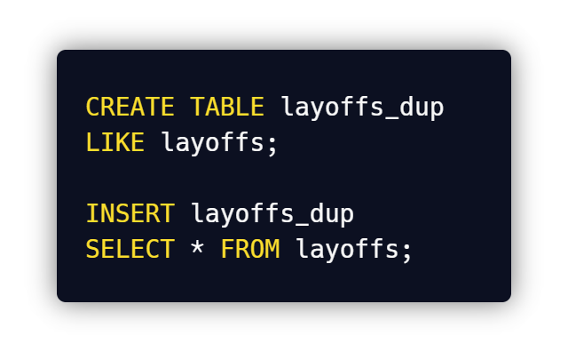

# Deleting Duplicate Records:

* Creating a ‘duplicate indicator’ column:
* To delete duplicate records, we first have to create a new column that acts as an indicator if a record is duplicate or not.
* We can do that with the window function **ROW_NUMBER ()**

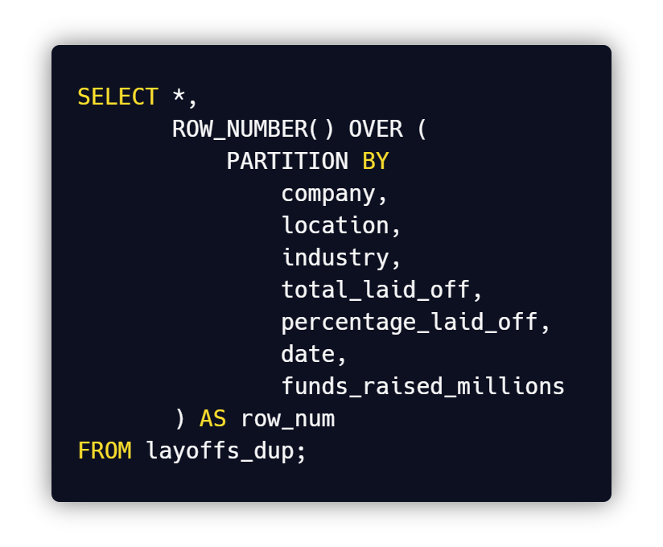

* This creates a separate column which identifies unique rows by assigning them with “1” and duplicates with values greater than “1”

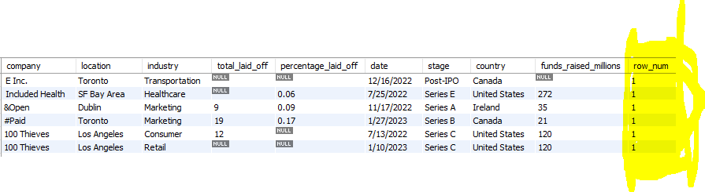

iii. Use ROW_NUMBER () to identify duplicates:  
Modify the query to find records whose “row_num” is greater 1 (Use either Subqueries or Common Table Expressions (CTEs)):

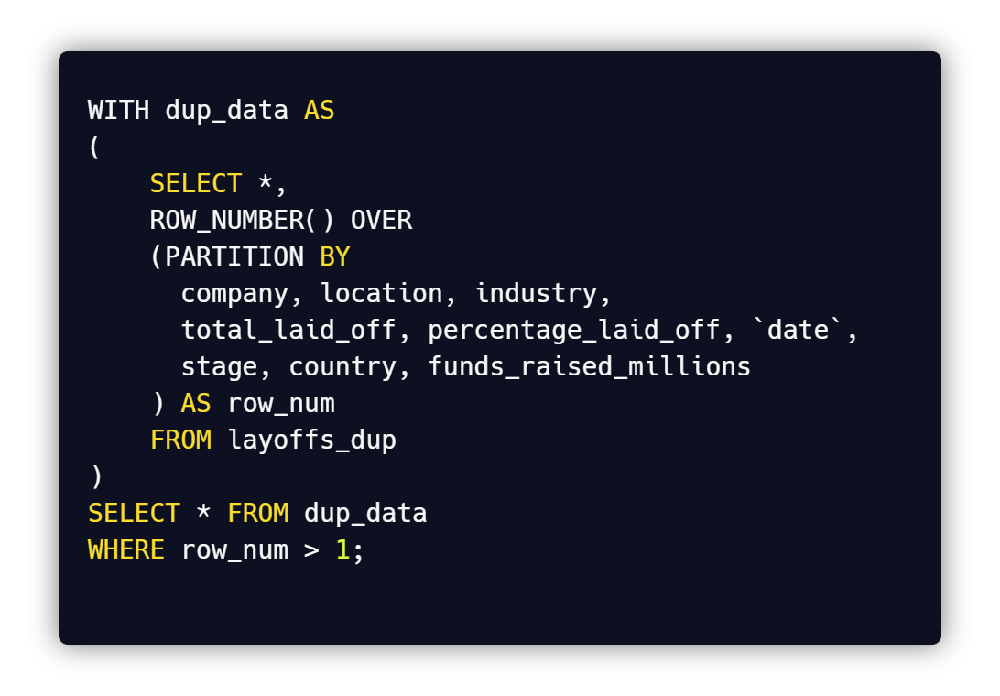

## Create another duplicate table for safe deletion of duplicate records:

* Since this step involves deletion of data, create another table to ensure safe deletion of files
* Add the ‘*layoffs_dup’* data into the new table and rename it ‘***layoffs_dup2’***

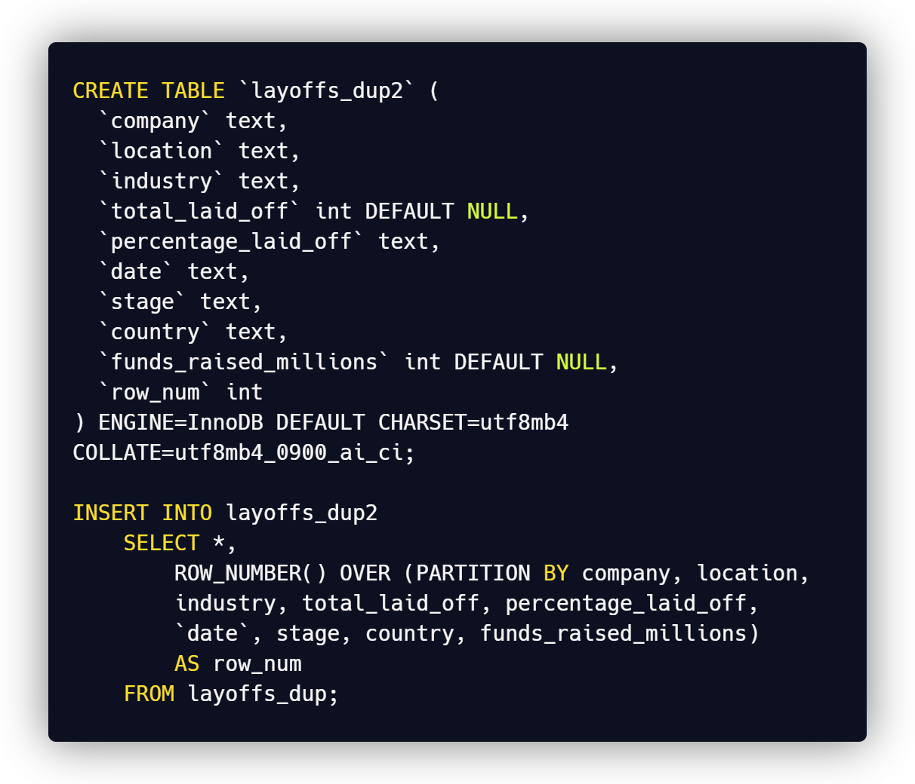

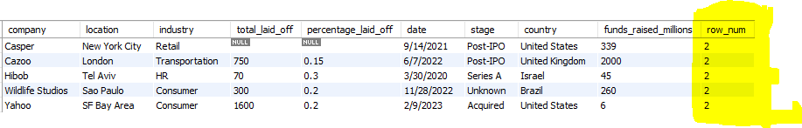

* Execute the same queries to find the duplicate records and delete those records from *‘layoffs_dup2’*

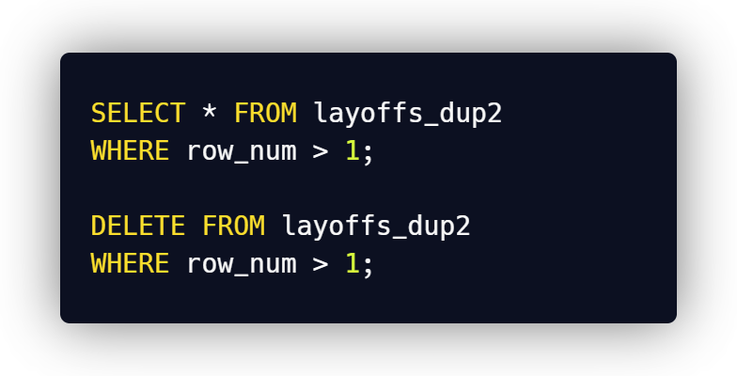

# *Standardizing the data:*

## Use TRIM () Function to remove the gaps before the names:

* TRIM () function removes spaces present before and after a company name

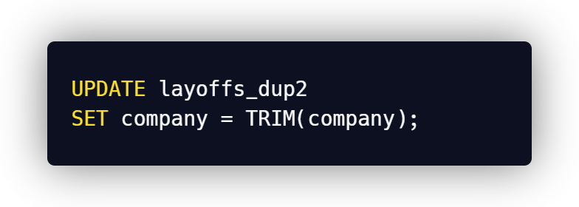

## Merge similarly named industries like ' crypto', 'crypto currency', 'crypto-currency':

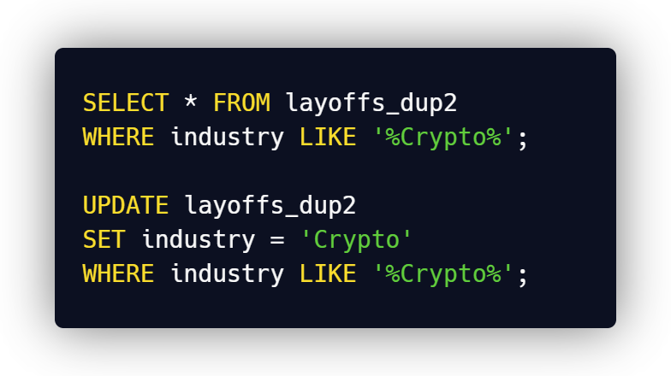

## Look for more unclean data in ‘countries’ columns with DISTINCT ():

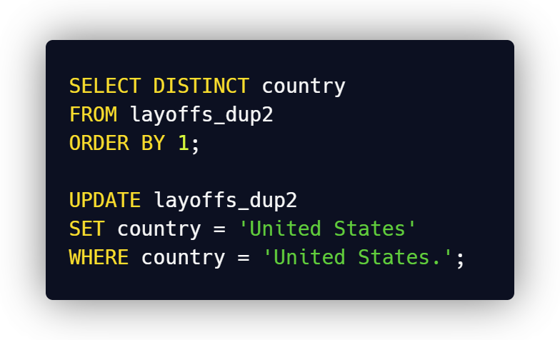

## Change formats of some columns like ‘date’:

* First convert the text in the ‘date’ column into data datatype with the help of **‘STR_TO_DATE ()’** function
* Then update the column values with the same **‘STR_TO_DATE ()’**
* Finally, change the datatype of the ‘date’ column from text to date datatype:

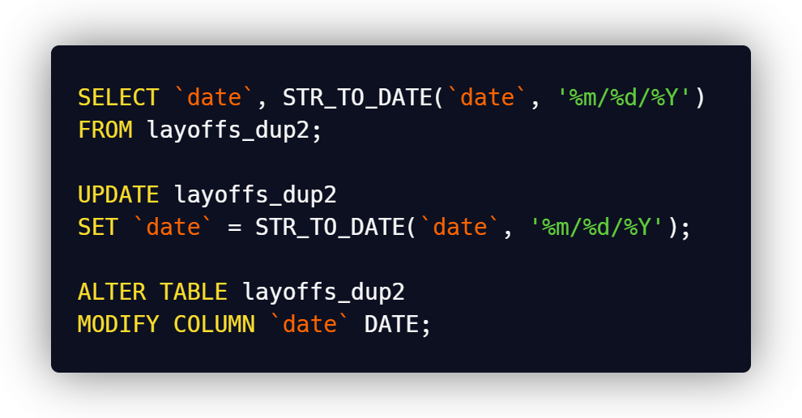

# *Dealing with NULL values*

## Converting blanks into null values for consistency:

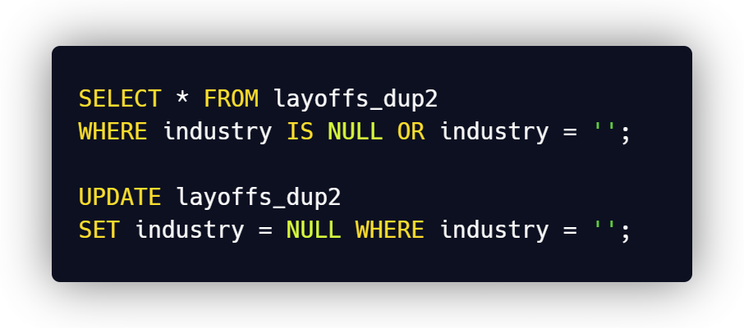

## Check for Possible Replacements:

* Find existing values for the same company to use as replacements

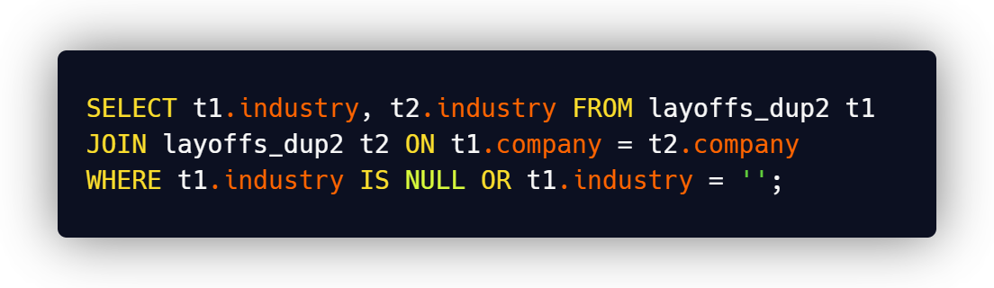

## Fill missing values:

* Update NULL industries using available values from the same company

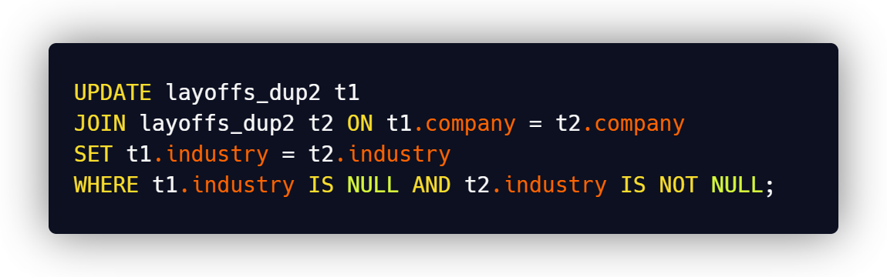

# *Deleting unnecessary data:*

## Deleting records that don’t play a big role in analysis:

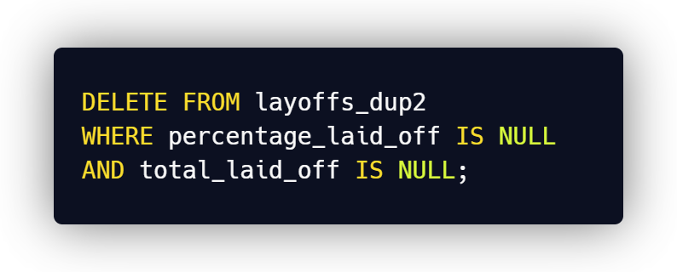

## Dropping the ‘row_num’ column:

* Row_num has been used just to identify the duplicate records, which isn’t of a big use

